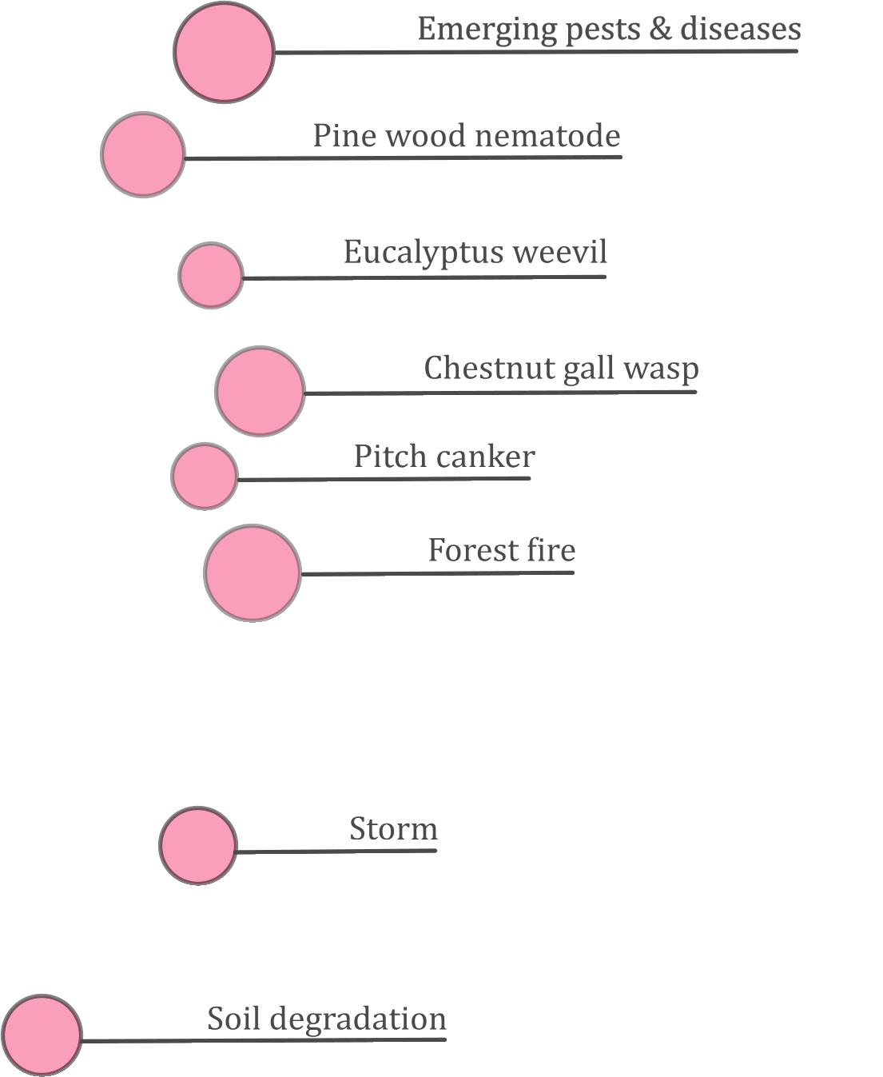

7-8 November 2018

Niemeyer Center

Avilés, Asturias

Spain
PLURIFOR
Technical Comittee

Agenda

Table of contents
Table of contents 1
Agenda 2

Agenda
DAY 1: 7 NOVEMBER  technical committee WP3 |  | Attendees: Partners only  Language: English  Venue: Niemeyer Center
11:30 | Arrival at site
12:00 | Lunch
13:30 | Start: Welcome address and agenda validation |  | Christophe Orazio  Juan Majada
14:00 | Task coordination:  - Audit results (Nick Carter)  - Budget and already spend expenses  - Issues for funds claim  Open questions |  | Christophe Orazio
16:00 | WP3 : Aim, 10 case studies, Methodology, Economic assessment, Expected results |  | Juan Majada
17:00 | End of Day 1

DAY 2: 8 NOVEMBER  technical committee WP3 |  | Attendees: Partners only  Language: English  Venue: Niemeyer center
8:00 | Feedback on evaluated risk managements plans |  | Risk management plan leaders
10:00 | Break
10:30 | WP3 Next steps |  | Juan Majada
11:150 | Silvalert application |  | Sarah Yoga
12:00 | WP4 |  | Sarah Yoga
12:30 | Lunch
14:00 | Visits  Cetemas foundation  Clonal eucalyptus trials
17:00 | End

Addess:
Niemeyer center
Av. del Zinc, s/n, 33490 Avilés, Asturias, Spain
http://www.niemeyercenter.org/
